# Compsoft Technologies



AN INTERNSHIP REPORT

ON

“QUOARA FOR ENGINERS”

**Bachelor of Engineering**

**In**

**Computer Science and Engineering**

Submitted by:

AMOGH.S.BHARADWAJ (1DT19CS013)

VISHWAJIT.H (1DT19CS051)

HARSH.V.CHALLA(1DT19CS054)



**DAYANANADA SAGAR ACADEMY OF TECHNOLOGY AND MANAGEMENT**

**2022**

# ABOUT THE COMPANY

We are a digital service provider that aims to provide software, designing and marketing solutions to individuals and businesses, we believe that service and quality is the key to success

We provide all kinds of technological and designing solutions from Billing Software to Web Designs or any custom demand that you may have. Experience the service like none other!

Some of our services include:

**Development** - We develop responsive, functional and super-fast websites.

We keep User Experience in mind while creating websites. A website should load quickly and should be accessible even on a small view-port and slow internet connection.

**Mobile Application** - We offer a wide range of professional Android, iOS & Hybrid app development services for our global clients, from a start up to a large enterprise.

**Design** - We offer professional Graphic design, Brochure design & Logo design. We are experts in crafting visual content to convey the right message to the customers.

**Consultancy** - We are here to provide you with expert advice on your design and development requirement.

**Videos** - We create a polished professional video that impresses your audience.

***Table of Contents***

Compsoft Technologies 1

ABOUT THE COMPANY 2

OVERVIEW OF THE PROJECT 5

Project Name: 5

Team Members: 5

ABOUT QES 6

TOOLS USED 7

HARDWARE REQUIREMENTS 7

SOFTWARE REQUIRMENTS 7

IMPLEMENTATION 8

Source Code (P1.HTML): 8

IMPLEMENTATION 14

Source Code (P1.CSS+P1.JS): 14

IMPLEMENTATION 24

Snapshots: 24

1. ACTIVATING VIRTUAL ENVIRONMENT 24

2. RUNNING SERVER 24

3. HOME PAGE 25

4. SIGNUP PAGE 25

5. LOGGING IN 26

6. LATEST QUESTIONS 26

7.ASK QUESTION 27

8. ANSWERING THE QUESTION (AKA COMMENT) 28

9. SEARCHING FOR QUESTIONS 29

10. LOGGING OUT 29

11. DATABASE OF USERS 30

12. DATABASE OF QUESTIONS 30

13. DATABASE OF COMMENTS 31

14.DATABASE OF LIKES 31

BIBLIOGRAPHY 32

About my TEAM 33

# OVERVIEW OF THE PROJECT

Project Name: Quora for Engineering Students

Team Members:

1. AMOGH.S.BHARADWAJ (1DT19CS013)
2. VISHWAJIT.H (1DT19CS051)
3. HARSH.V.CHALLA (1DT19CS054)

This project is based on Web Development And its Applications. The main objective of this project is to learn the implementation of HTML, CSS and JavaScript. The basic webpage of this project is created using HTML and styling of the webpage is done using CSS.

# ABOUT QES

QES is a question-and-answer website for Engineering students. We tend to create a flagship site similar to the Stack Overflow Site of the Stack Exchange Network, created in 2008 by Jeff Atwood and Joel Spolsky. QES features questions and answers on a wide range of topics in Engineering. Our notion of a better-connected engineering community to tackle all kinds of academic and non Academical questions and problems would make the engineering community better. Establishing a community-based platform like this would help bypass the location barrier for Engineering students.

# TOOLS USED

## HARDWARE REQUIREMENTS

* Processor - Intel 486/Pentium processor or better
* Processor Speed - 500 MHz or above
* Hard Disk - 20GB(approx.)
* RAM - 64MB or above
* Storage Space - Approx. 2MB

## SOFTWARE REQUIRMENTS

* IDE: VISUAL STUDIO CODE
* LANGUAGES USED:

1. HTML
2. JS
3. CSS
4. PYTHON
5. DJANGO

* DATABASE: SQLITE

# IMPLEMENTATION

## Source Code (P1.HTML):

{% load static %}

<!doctype html>

<html lang="en">

<head>

    <meta charset="UTF-8">

    <meta name="viewport"

          content="width=device-width, user-scalable=no, initial-scale=1.0, maximum-scale=1.0, minimum-scale=1.0">

    <meta http-equiv="X-UA-Compatible" content="ie=edge">

    <title>QES</title>

*<!-- <link rel="shortcut icon" href="https://img.icons8.com/nolan/64/unchecked-circle.png">*

*<link rel="apple-touch-icon" href=".../icons8-round-57.png">*

*<link rel="apple-touch-icon" href="https://cdn.sstatic.net/Sites/stackoverflow/Img/apple-touch-icon.png?v=c78bd457575a"> -->*

    <link rel="image_src" href="https://cdn.sstatic.net/Sites/stackoverflow/Img/apple-touch-icon.png?v=c78bd457575a">

    <link rel="stylesheet" href="https://cdnjs.cloudflare.com/ajax/libs/font-awesome/5.14.0/css/all.min.css" integrity="sha512-1PKOgIY59xJ8Co8+NE6FZ+LOAZKjy+KY8iq0G4B3CyeY6wYHN3yt9PW0XpSriVlkMXe40PTKnXrLnZ9+fkDaog==" crossorigin="anonymous" />

*<!-- <link rel="stylesheet" href="assets/css/main.css"> -->*

    <link rel="stylesheet" href="https://maxcdn.bootstrapcdn.com/bootstrap/4.0.0/css/bootstrap.min.css" integrity="sha384-Gn5384xqQ1aoWXA+058RXPxPg6fy4IWvTNh0E263XmFcJlSAwiGgFAW/dAiS6JXm" crossorigin="anonymous">

    <link rel="stylesheet" href="{% static 'main.css' %}">

*<!-- <link href="https://cdn.jsdelivr.net/npm/bootstrap@5.1.1/dist/css/bootstrap.min.css" rel="stylesheet" integrity="sha384-F3w7mX95PdgyTmZZMECAngseQB83DfGTowi0iMjiWaeVhAn4FJkqJByhZMI3AhiU" crossorigin="anonymous"> -->*

*<!-- Favicons -->*

  <link href="static/assets/img/favicon.png" rel="icon">

  <link href="static/assets/img/apple-touch-icon.png" rel="apple-touch-icon">

</head>

<body>

<header>

<div class="nav-container">

    <nav>

        <div class="nav-brand">

*<!--<a href="https://img.icons8.com/nolan/64/unchecked-circle.png" > -->*

                <link href="static/assets/img/favicon.png" rel="icon">

*<!-- <class="nav-icon" img src="https://img.icons8.com/nolan/64/unchecked-circle.png"/> -->*

                <a href="{% url 'stackbase:home' %}" style="text-decoration: none; color: black;"><div class="nav-icon-text"><span class="nav-bold-text">QES</span></a>

*<!--<div class="nav-icon">stack <span class="nav-bold-text">overflow</span> -->*

*<!--<a href="{% url 'stackbase:home' %}"  class="logo me-auto"><img src="static/assets/img/logo.png" alt=""></a>-->*

                </div>

            </a>

        </div>

        <div class="nav-base-links">

        </div>

        <div class="nav-search">

            <div class="search-container">

                <i class="fas fa-search"></i>

                <form action="" method="GET">

                    <input type="text" id="" name="search-area" placeholder="Search" >

                    <button type="submit" style="margin-left: 880px; border-radius: 25px; border: none; padding: 4px;">Search</button>

                </form>

            </div>

            <div class="search-hints">

                <div class="search-arrow-up"></div>

                <div class="search-hint-body">

                    <div class="hints-grid-column">

                        <div class="hint-text"><span>[tag] </span> search within a tag</div>

                        <div class="hint-text"><span>user:1234 </span>  search by author</div>

                        <div class="hint-text"><span>"words here"</span> exact phrase </div>

                    </div>

                    <div class="hints-grid-column">

                        <div class="hint-text"><span>answers:0</span> unanswered questions</div>

                        <div class="hint-text"><span> score:3  </span> posts with a 3+ score</div>

                    </div>

                </div>

                <div class="search-hint-footer">

                    <a href="#" class="btn">Ask a question</a>

                    <a href="#" class="search-help">Search help</a>

                </div>

            </div>

        </div>

        <div class="nav-right-buttons">

            <div class="search-btn">

                <i class="fas fa-search"></i>

            </div>

            {% if user.is_authenticated %}

*<!-- <a href="{% url 'login' %}" class="btn btn-login">Profile</a> -->*

                <a href="{% url 'logout' %}" class="btn btn-register">Logout</a>

            {% else %}

                <a href="{% url 'login' %}" class="btn btn-login">Log in</a>

                <a href="{% url 'register' %}" class="btn btn-register">Sign up</a>

            {% endif %}

        </div>

    </nav>

</div>

*<!-- <h1 style="font-size: 20px;">hello</h1> -->*

    <div style="margin-top: 10px;">

        {% if messages %}

        {% for message in messages %}

      <div class="alert alert-{{ message.tags }}" role="alert">

        <h4 style="text-align: center;">{{ message }}</h4>

      </div>

      {% endfor %}

    {% endif %}

    </div>

</header>

*<!-- Add block content here -->*

*<!-- Add enbdblock content here -->*

{% block content %}

{% endblock content %}

<footer class="footer">

<div class="container">

    <div class="footer-content">

*<!-- <div class="footer-icon">*

*<img src="https://img.icons8.com/nolan/90/unchecked-circle.png"width="400"*

*height="500"/>*

*</div> -->*

        <div class="footer-another-links">

            <div class="copyright">

                <p>site design / logo QES 2022 &copy by Harsh,Amogh,Vishwajit </p>

            </div>

        </div>

    </div>

</div>

</footer>

*<!-- <script src="assets/js/main.js"></script> -->*

<script src="{% static 'main.js' %}"></script>

<script src="https://cdn.jsdelivr.net/npm/@popperjs/core@2.9.3/dist/umd/popper.min.js" integrity="sha384-W8fXfP3gkOKtndU4JGtKDvXbO53Wy8SZCQHczT5FMiiqmQfUpWbYdTil/SxwZgAN" crossorigin="anonymous"></script>

<script src="https://cdn.jsdelivr.net/npm/bootstrap@5.1.1/dist/js/bootstrap.min.js" integrity="sha384-skAcpIdS7UcVUC05LJ9Dxay8AXcDYfBJqt1CJ85S/CFujBsIzCIv+l9liuYLaMQ/" crossorigin="anonymous"></script>

</body>

</html>

# IMPLEMENTATION

## Source Code (P1.CSS+P1.JS):

/* Global Styles */

:root {

--white: #fff;

--black: #0c0d0e;

--orange: #f48024;

--yellow: #fbf2d4;

--green: #5eba7d;

--blue: #0077cc;

--powder: #e1ecf4;

--red: #d1383d;

--black-025: #fafafb;

--black-050: #eff0f1;

--black-075: #e4e6e8;

--black-100: #d6d9dc;

--black-150: #c8ccd0;

--black-200: #bbc0c4;

--black-300: #9fa6ad;

--black-350: #9199a1;

--black-400: #848d95;

--black-500: #6a737c;

--black-600: #535a60;

--black-700: #3c4146;

--black-750: #2f3337;

--black-800: #242729;

--black-900: #0c0d0e;

--orange-050: #fff7f2;

--orange-100: #fee3cf;

--green-700: #2f6f44;

--green-800: #29603b;

--green-900: #1e472c;

--yellow-050: #fdf7e3;

--yellow-100: #fbf2d4;

--yellow-200: #f1e5bc;

--yellow-300: #e6d178;

--yellow-400: #e9c63f;

--yellow-500: #ddb624;

--yellow-600: #cea51b;

--gold-darker: #f1b600;

--silver: #b4b8bc;

--silver-lighter: #e8e8e8;

--silver-darker: #9a9c9f;

--bronze: #caa789;

--bronze-lighter: #f2e9e1;

--bronze-darker: #ab825f;

--fc-dark: #0c0d0e;

--fc-medium: #3c4146;

--fc-light: #6a737c;

--focus-ring: rgba(0,149,255,0.15);

--focus-ring-success: rgba(166,217,183,0.4);

--focus-ring-warning: rgba(233,198,63,0.4);

--focus-ring-error: rgba(192,45,46,0.15);

--focus-ring-muted: rgba(36,39,41,0.1);

--bs-sm: 0 1px 2px rgba(0,0,0,0.05),0 1px 4px rgba(0,0,0,0.05),0 2px 8px rgba(0,0,0,0.05);

--bs-md: 0 1px 3px rgba(0,0,0,0.06),0 2px 6px rgba(0,0,0,0.06),0 3px 8px rgba(0,0,0,0.09);

--bs-lg: 0 1px 4px rgba(0,0,0,0.09),0 3px 8px rgba(0,0,0,0.09),0 4px 13px rgba(0,0,0,0.13);

--scrollbar: rgba(0,0,0,0.2);

--highlight-bg: #f6f6f6;

--highlight-color: #2f3337;

--highlight-comment: #656e77;

--highlight-punctuation: var(--black-600);

--highlight-namespace: #b75501;

--highlight-attribute: #015692;

--highlight-literal: #b75501;

--highlight-symbol: #803378;

--highlight-keyword: #015692;

--highlight-variable: #54790d;

--highlight-addition: #2f6f44;

--highlight-deletion: #c02d2e;

--dark-blue:#2b2d6e;

--magnolia:#f7f6f9;

}

@font-face {

font-family: "Source Sans Pro";

font-style: normal;

font-weight: 400;

src: local("Source Sans Pro Regular"), local("SourceSans Pro-Regular"), local("Source Sans Pro 400"), local("SourceSans Pro-400"), local("Source Sans Pro"), url("https://cdn.sstatic.net/Fonts/source-sans-pro/source-sans-pro-regular-webfont.woff?v=993db0ec4347") format("woff");

}

@font-face {

font-family: "Source Sans Pro Bold";

font-style: normal;

font-weight: 700;

src: local("Source Sans Pro Bold Bold"), local("SourceSans Pro Bold-Bold"), local("Source Sans Pro Bold 700"), local("SourceSans Pro Bold-700"), url("https://cdn.sstatic.net/Fonts/source-sans-pro/source-sans-pro-bold-webfont.woff?v=f52ccc0bbce9") format("woff");

}

@font-face {

font-family: "Roboto Slab";

font-style: normal;

font-weight: 400;

src: local("Roboto Slab Regular"), local("RobotoSlab-Regular"), local("Roboto Slab 400"), local("RobotoSlab-400"), local("Roboto Slab"), url("https://cdn.sstatic.net/Fonts/roboto-slab/roboto-slab-regular-webfont.woff?v=a75088a46d79") format("woff");

}

@font-face {

font-family: "Roboto Slab Bold";

font-style: normal;

font-weight: 700;

src: local("Roboto Slab Bold Bold"), local("RobotoSlab Bold-Bold"), local("Roboto Slab Bold 700"), local("RobotoSlab Bold-700"), url("https://cdn.sstatic.net/Fonts/roboto-slab/roboto-slab-bold-webfont.woff?v=719d1c709127") format("woff");

}

*, *::before, *::after {

margin: 0;

padding: 0;

box-sizing: border-box;

}

html {

font-family: Arial, "Helvetica Neue", Helvetica, sans-serif;

font-size: 10px;

color: var(--black-800);

}

.container {

width: 100%;

max-width: 126.4rem;

margin: 0 auto;

padding: 0 1.5rem;

}

section {

padding: 5rem 0;

}

ul {

list-style: none;

}

a {

text-decoration: none;

color: var(--blue-600);

cursor: pointer;

}

img {

width: 100%;

max-width: 100%;

height: auto;

}

.btn {

text-align: center;

font-size: 1.3rem;

border-radius: 3px;

transition: all 0.5s;

padding: 1.3rem 2.5rem;

}

.btn-orange {

background-color: var(--orange);

color: var(--white);

}

.btn-dark-blue {

background-color: var(--dark-blue);

color: var(--white);

}

/* Header */

header {

width: 100%;

height: 50px;

background-color: var(--black-025);

border-top: 3px solid var(--orange);

position: fixed;

left: 0;

top: 0;

z-index: 99;

box-shadow: var(--bs-sm);

}

content-section {

background: #ffffff;

/* border-radius: 20px; */

padding: 10px 20px;

/* border: 1px solid #dddddd; */

border-radius: 10px;

margin-bottom: 20px;

}

.search-container {

width: 100%;

border: 1px solid var(--black-200);

border-radius: 3px;

padding: 0.8rem;

background-color: var(--white);

display: flex;

align-items: center;

}

.search-container i {

color: var(--black-200);

font-size: 1.5rem;

font-weight: 600;

}

.search-container input[type=text] {

flex: 1 1 auto;

margin-left: 0.5rem;

border: none;

outline: none;

color: var(--black-700);

}

.search-container input[type=text]::placeholder {

color: var(--black-200);

}

.search-container:focus-within {

border-color: var(--blue-300);

box-shadow: 0 0 0 0.4rem var(--focus-ring);

}

.search-btn {

height: 100%;

align-items: center;

justify-content: center;

padding: 0 1rem;

cursor: pointer;

display: none;

margin-right: 1rem;

}

.search-btn i {

font-size: 1.7rem;

color: var(--black-700);

}

.search-btn:hover {

background-color: var(--silver-lighter);

}

.search-hints {

display: none;

position: absolute;

top: 5rem;

left: 0;

width: 100%;

background-color: var(--white);

border-radius: 0.3rem;

box-shadow: var(--bs-lg);

}

.search-hints.open {

display: block;

}

.search-arrow-up {

position: absolute;

content: "";

top: -1.2rem;

height: 1.2rem;

width: 100%;

overflow: hidden;

}

.search-arrow-up:before {

position: absolute;

content: "";

top: 1.2rem;

left: 2rem;

width: 1.2rem;

height: 1.2rem;

background-color: var(--white);

border: 1px solid var(--black-150);

box-shadow: 2px 0 8px rgba(59, 64, 69, 0.1);

transform: translate(-50%, -50%) rotate(45deg);

transition: all 0.2s;

}

.search-hint-body {

border-bottom: 1px solid var(--black-075);

padding: 1.2rem 1.2rem 0;

display: flex;

}

.hints-grid-column {

flex-basis: 50%;

}

# IMPLEMENTATION

## Snapshots:

### 1. ACTIVATING VIRTUAL ENVIRONMENT

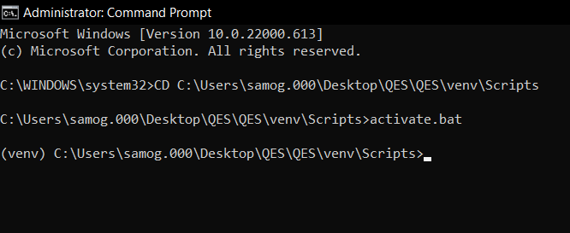

### 2. RUNNING SERVER

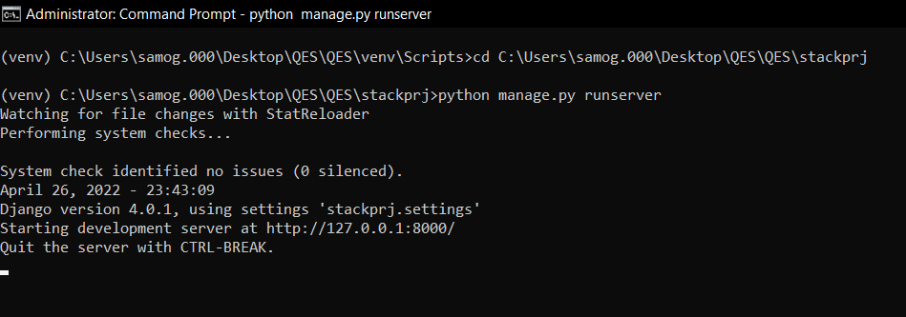

3. HOME PAGE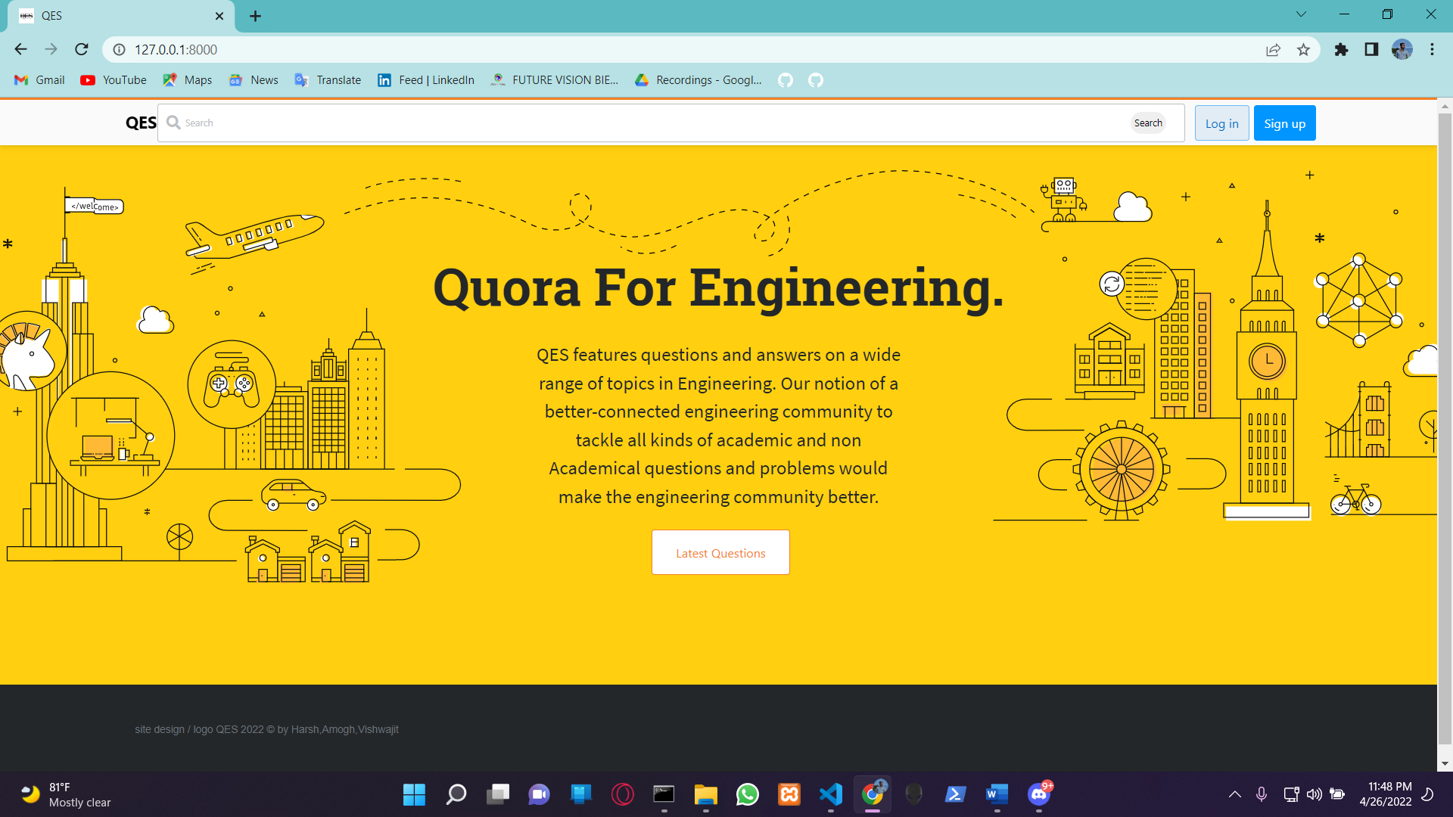

### 4. SIGNUP PAGE

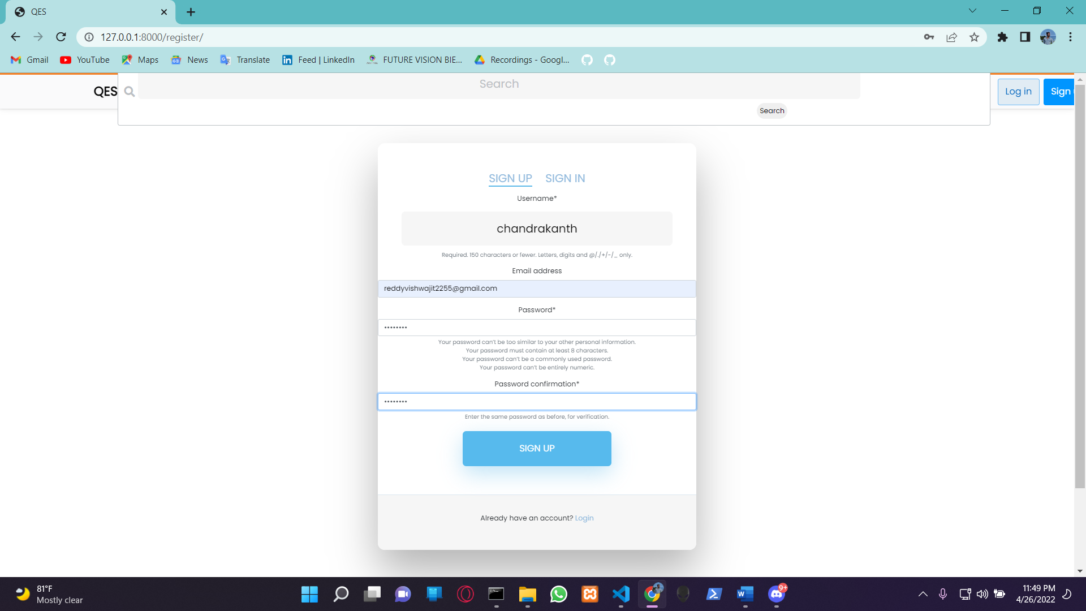

### 5. LOGGING IN

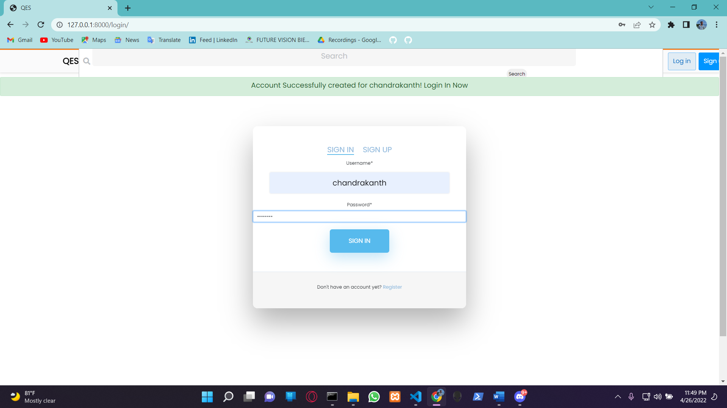

### 6. LATEST QUESTIONS

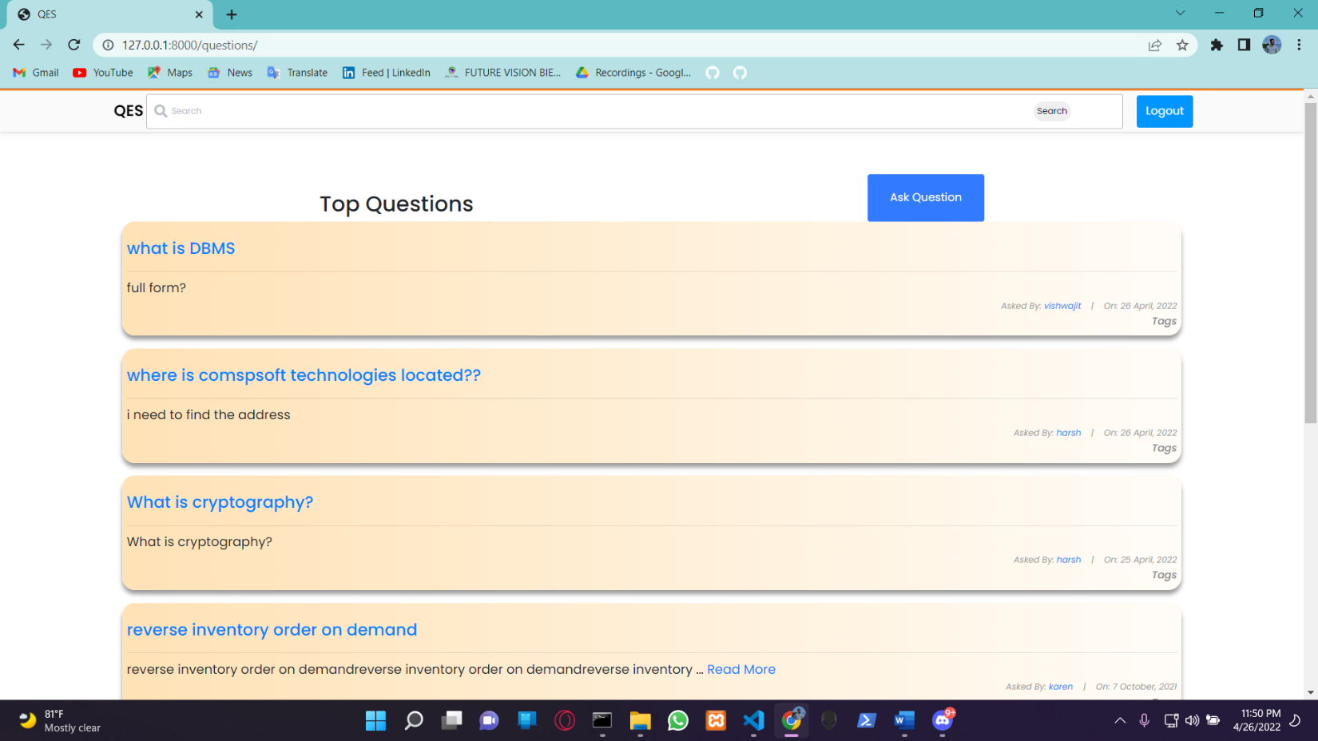

### 7.ASK QUESTION

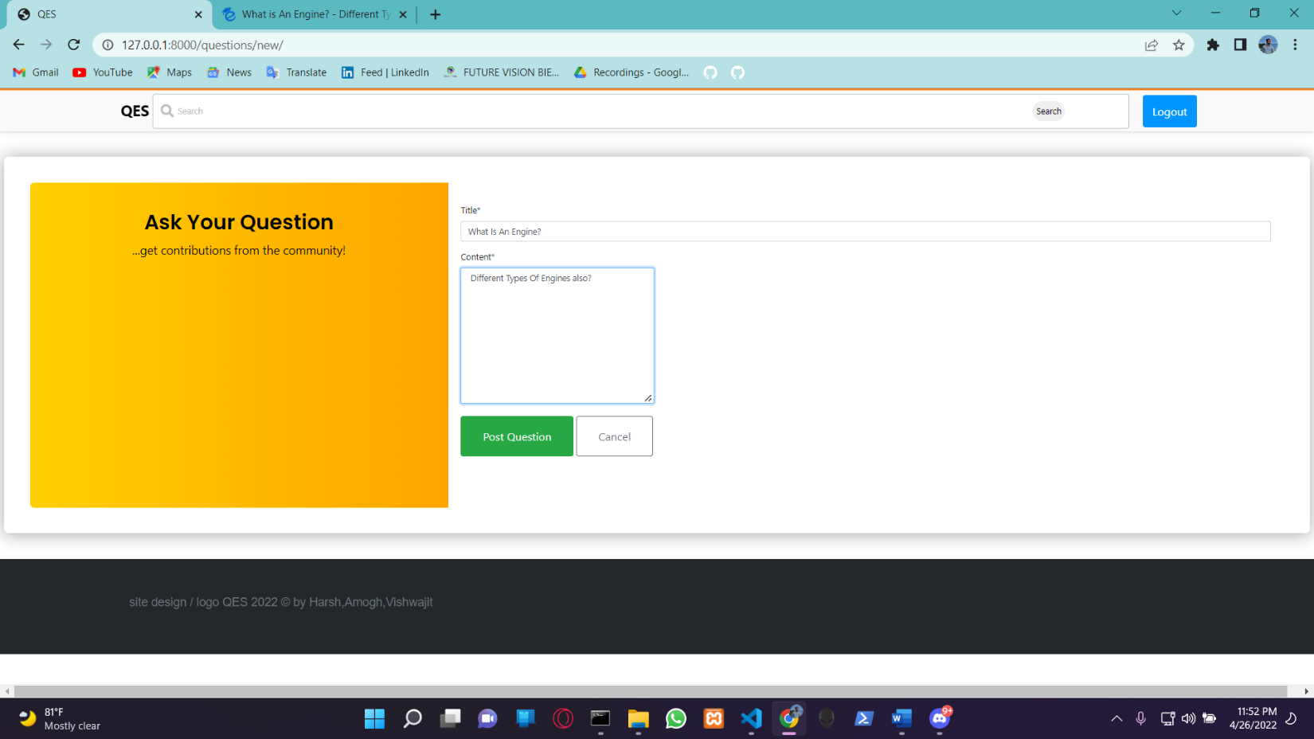

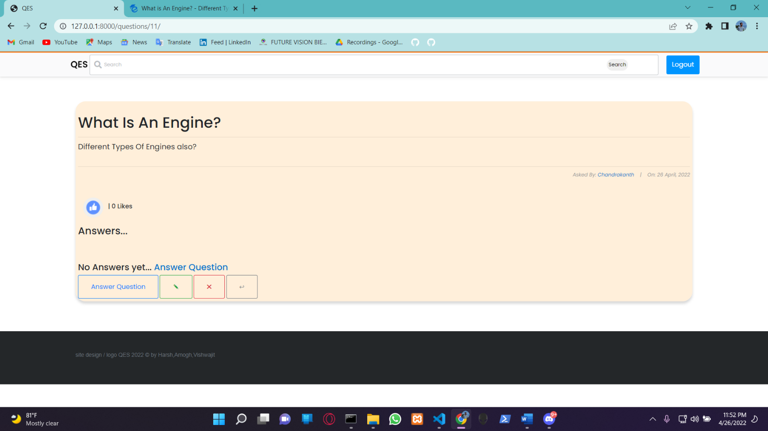

### 8. ANSWERING THE QUESTION (AKA COMMENT)

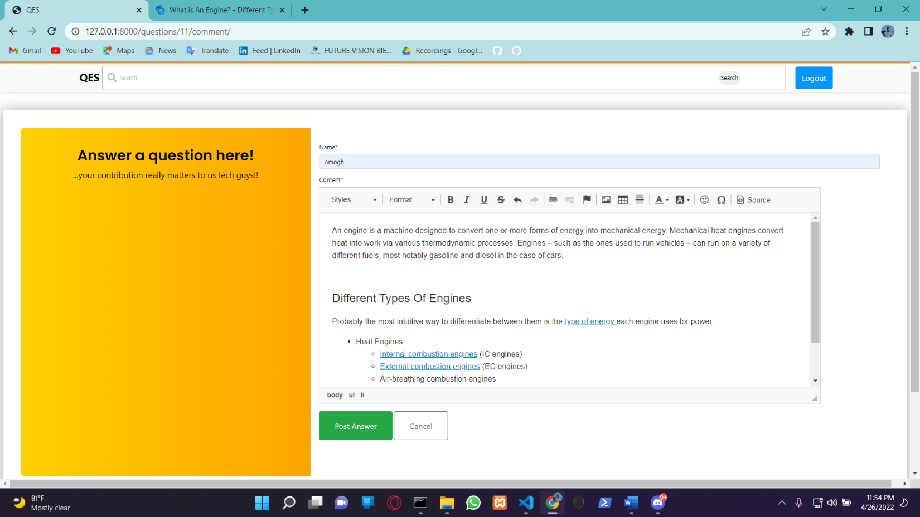

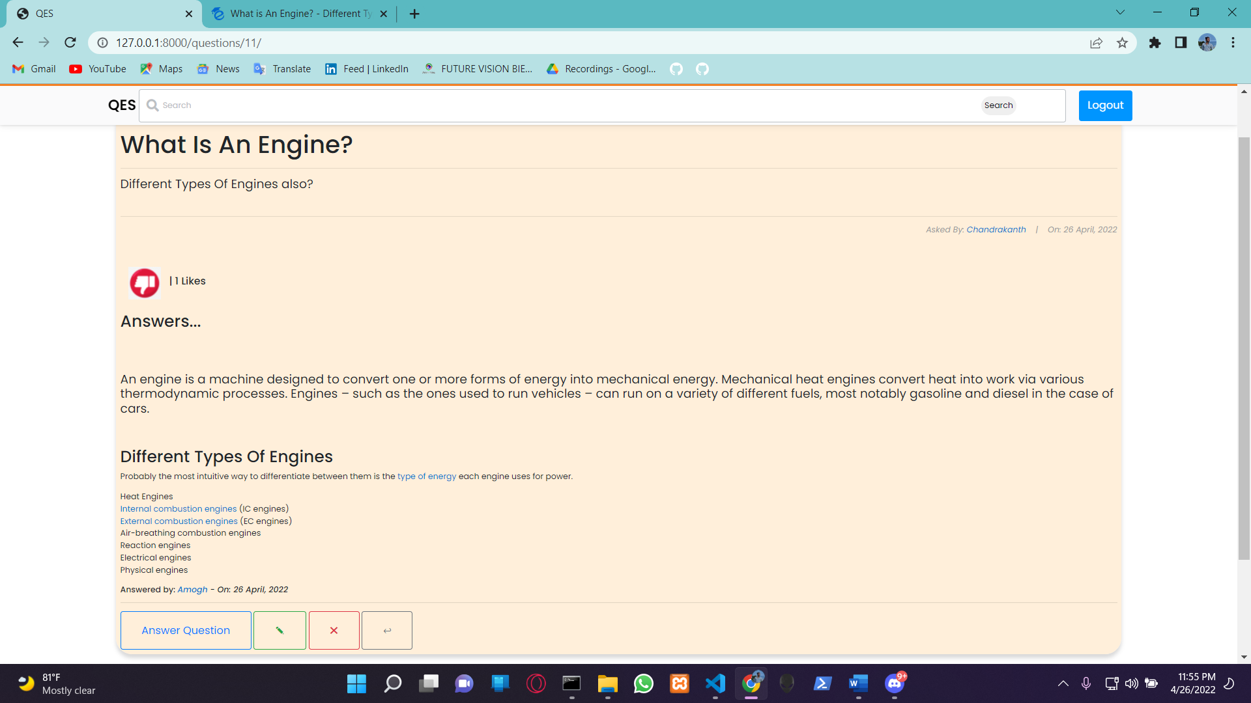

### 9. SEARCHING FOR QUESTIONS

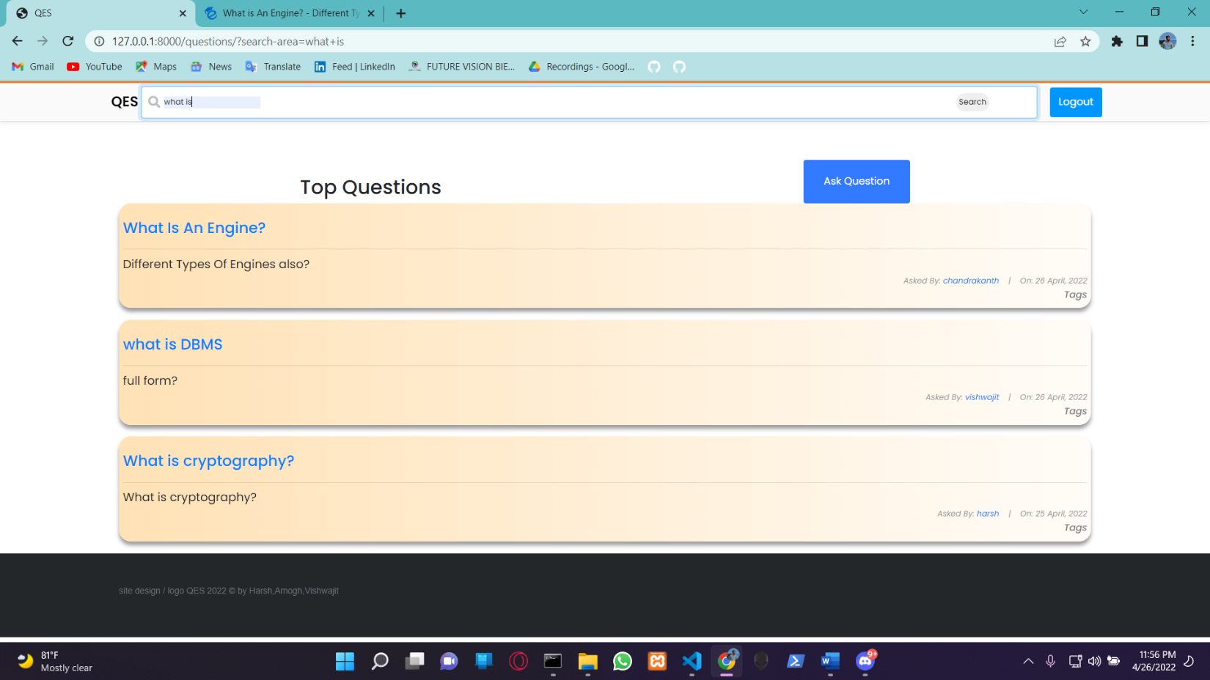

### 10. LOGGING OUT

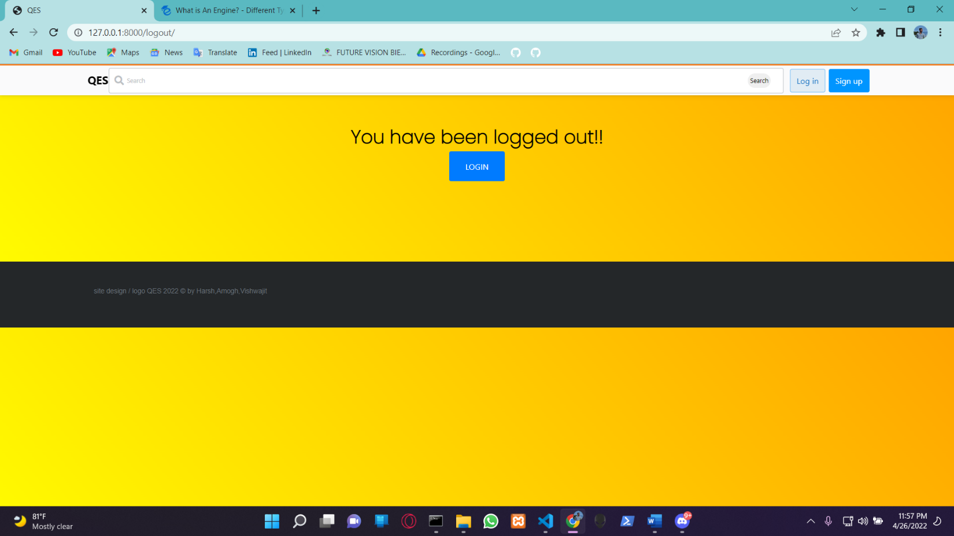

### 11. DATABASE OF USERS

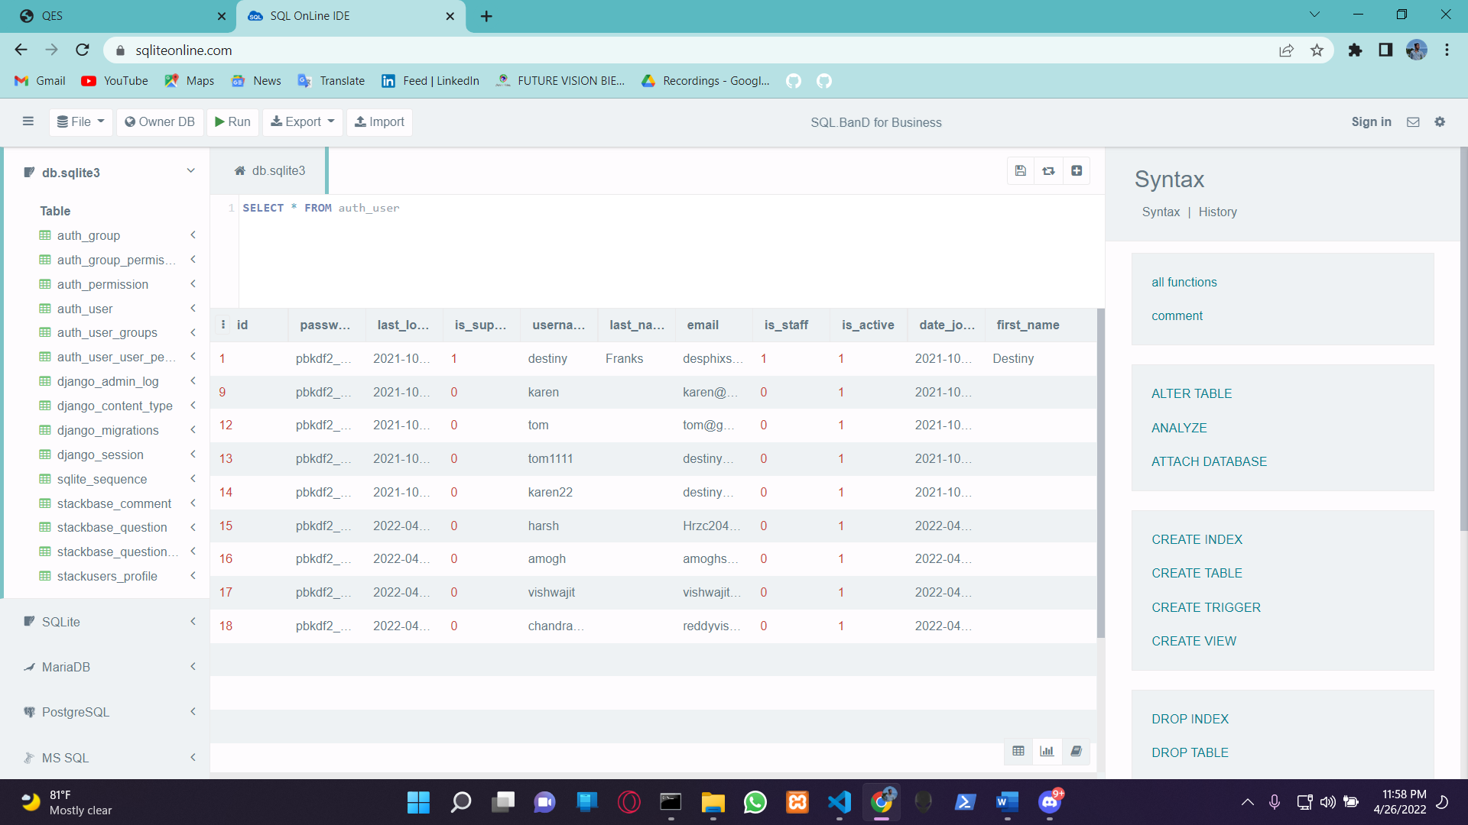

### 12. DATABASE OF QUESTIONS

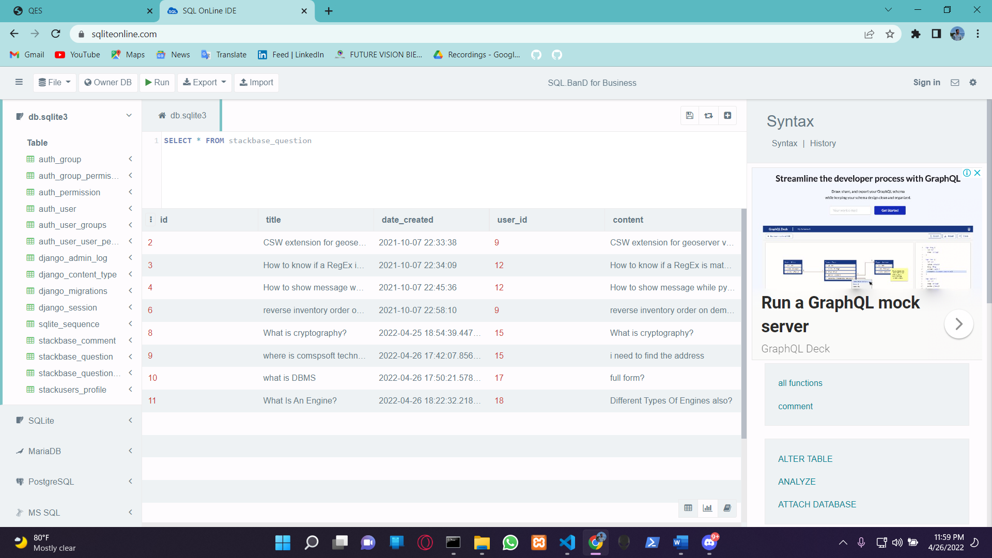

### 13. DATABASE OF COMMENTS

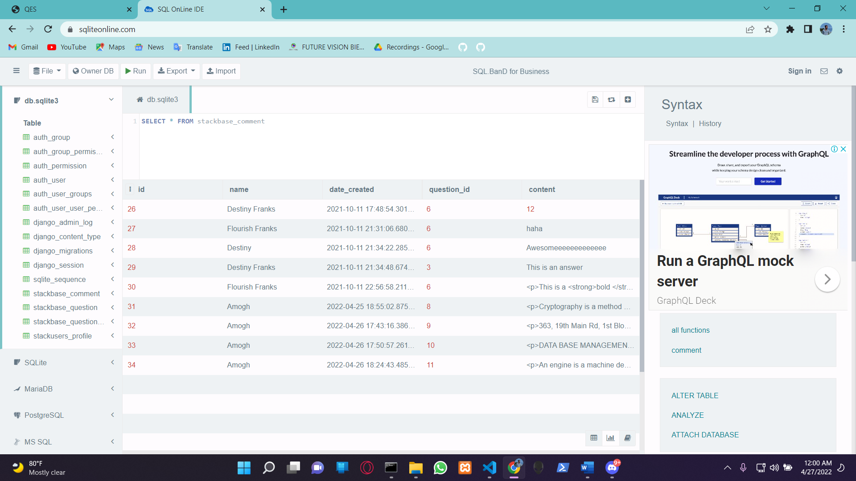

### 14.DATABASE OF LIKES

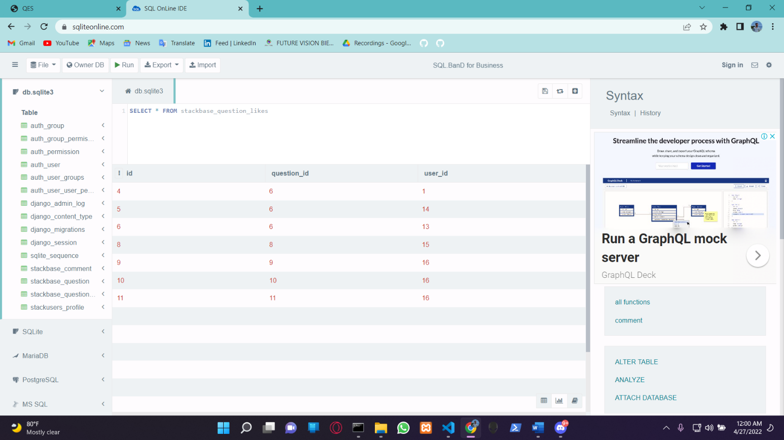

# BIBLIOGRAPHY

* + https://[www.w3schools.com](http://www.w3schools.com/)
  + https://[www.geeksforgeeks.org](http://www.geeksforgeeks.org/)
  + https://freefrontend.com

# About my TEAM

AMOGH.S.BHARADWAJ (1DT19CS013) - **Leader** of the team worked extensively in Pyhton,Django Functions And front end designing ,also coordinating all the tasks between all the components of the project

HARSH.V.CHALLA(1DT19CS054)- Contributed in accomplishment of the project by extensively working partially in front end development of the website with Html Css and in Pyhthon Django functions

VISHWAJIT.H (1DT19CS051) - Worked in smooth connectivity of all the parts of the project and partially helped in front and backend development